**Given a file, replace all occurrence of the word "give" with "learning" from 5th line till the end in only those lines that contain the word "welcome"**

* First, we need to create a folder, and we need to create a file in with some text on that file about 8 lines.

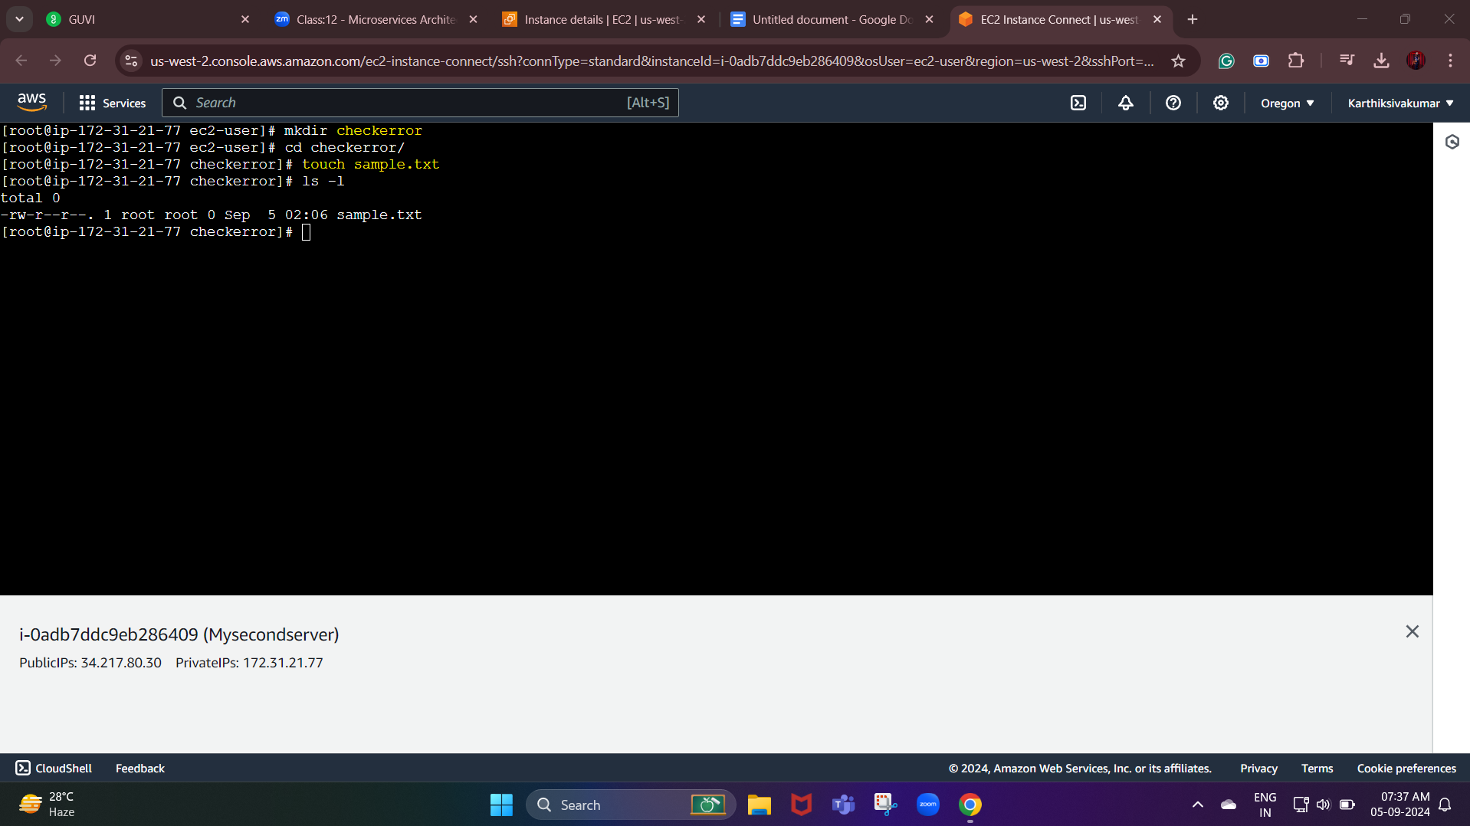

**We are going to** **replace all occurrence of the word "give" with "learning" from 5th line till the end in only those lines that contain the word "welcome"**

**That has been highlighted in the below screenshot.**

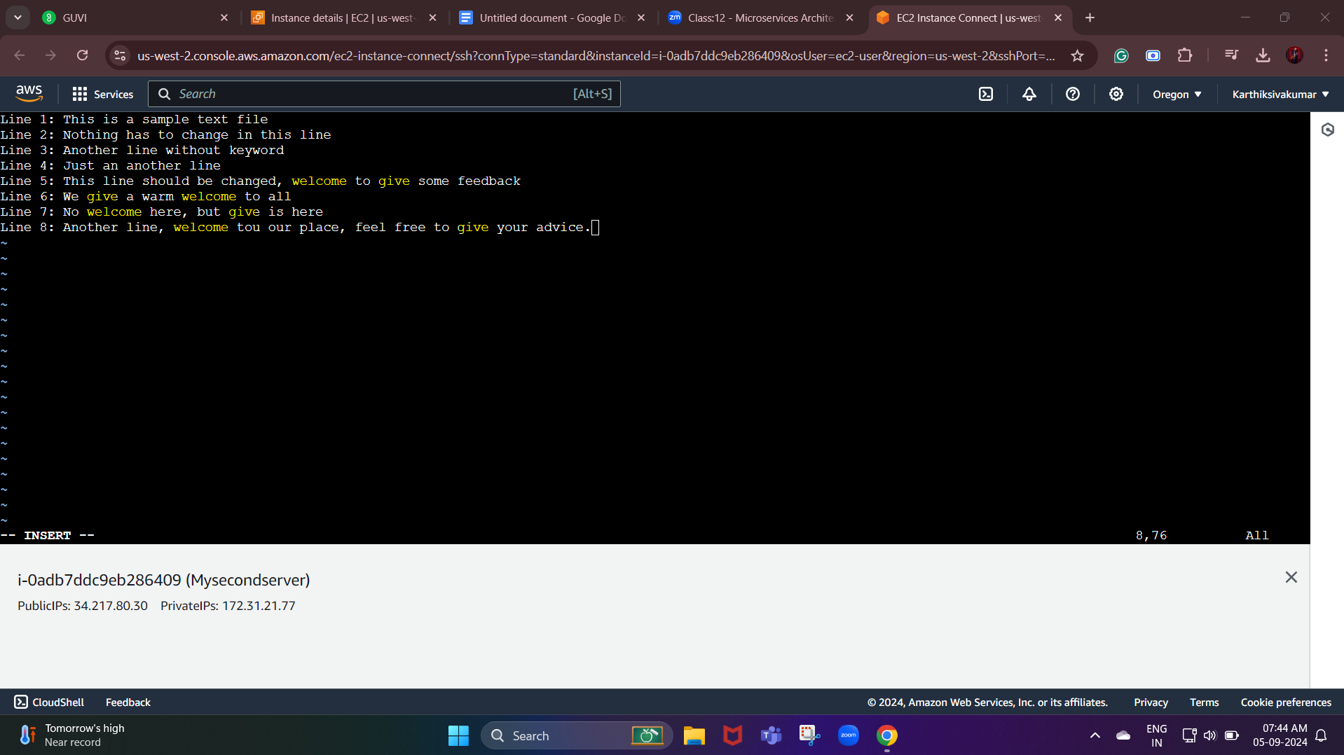

Now we need to create another file then we need to write a code:

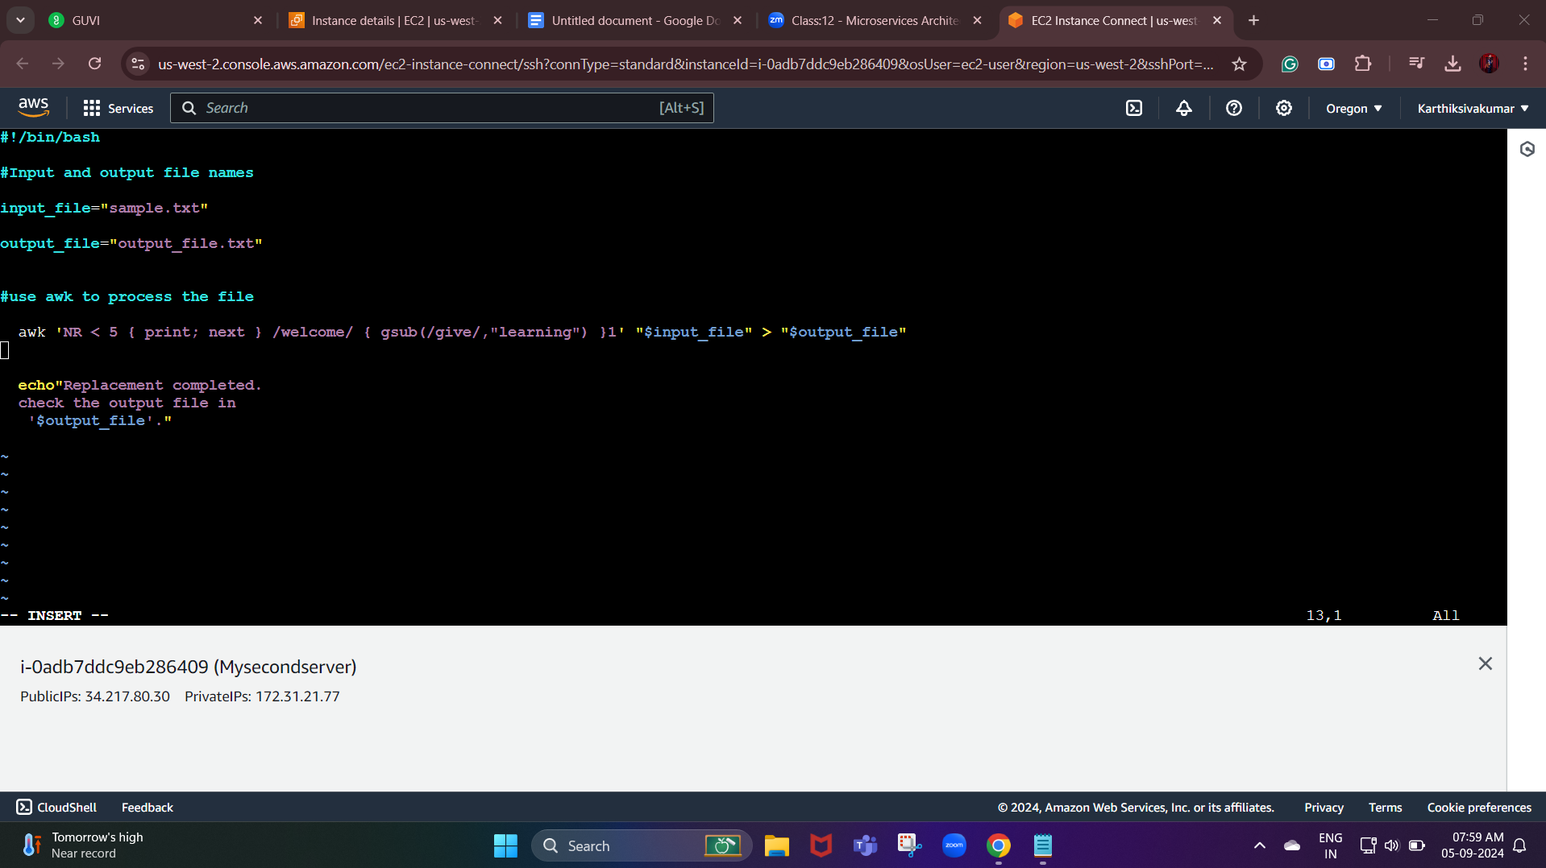

awk 'NR < 5 { print; next } /welcome/ { gsub(/give/,"learning") }1' "$input_file" > "$output_file"

AWK is suitable for pattern search and processing. The script runs to search one or more files to identify matching patterns and if the said patterns perform specific tasks. AWK is most often used for processing files.

**'NR < 5 { print; next }** : this part of awk command processes lines 1 to 4 and prints them unchanged.

**/welcome/ { gsub(/give/,"learning") }** : This checks if the line contains the word "welcome" if it does it replaces all occurances of "give" with "learning"

**gsub** (replacement,string_var) : Puts the replacement string The gsub() function stands for "global substitution" and it is primarily used for replacing all occurrences of a specified pattern within a given string with another pattern.

**1** : This is shortform for {print} in awk . it prints every line, whether it was modified or not

After running the code:

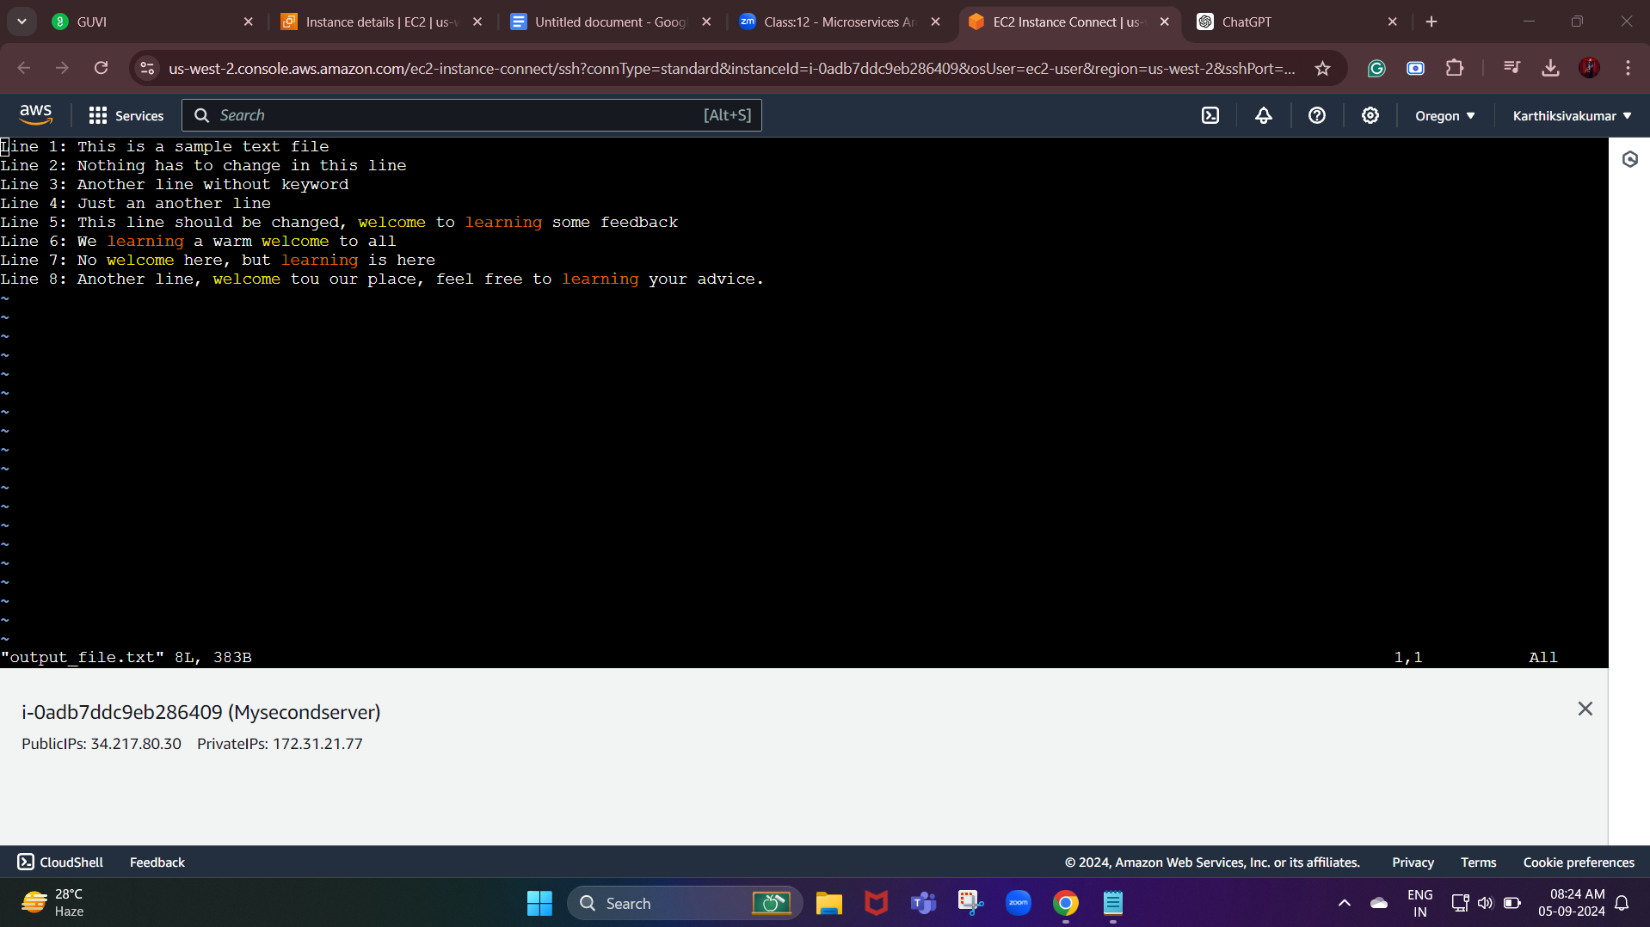

**We can see that** **the word "give" with "learning" from 5th line till the end in only those lines that contain the word "welcome"**

**This is my final result**

**To run ./new_replace.sh**